

Actividad [#3] – [Proyecto final] [Ingles para los negocios 1]

Ingeniería en Desarrollo de Software

**Tutor: Fatima Fernandez**

**Alumno: Manuel Enrique Ramirez Lopez**

**Fecha: 12/02/2022**

# *Indice*

*Indice* 2

*Desarrollo* 3

*Capturas de pantalla* 4

*Conclucion* 5

# *Desarrollo*

***5 reasons to choose to migrate the system***

1. Improve interface aspects and additional functions for greater productivity in the system and its representations, that is, it is more intuitive and its handling is made easier for collaborators
2. Create a union of the various systems that currently operate in our company so that employees become more familiar with the use of the same system and save time in trainin**g**
3. More efficient system and save resources on our servers to give priority to areas that require it or if "extra power" is required at times of utmost importance (seasons)
4. By requiring fewer resources in an individual computer, it gives the possibility of increasing the number of computer equipment within areas to make the operation more efficient.
5. Ease of installation in current equipment with the requirements used for its correct operation and thanks to the corporate network it can be installed and maintained remotely

How is the implementation process?

The development team is made up of 6 members Manuel, David, Jorge, Sara, Olivia, Yessenia.

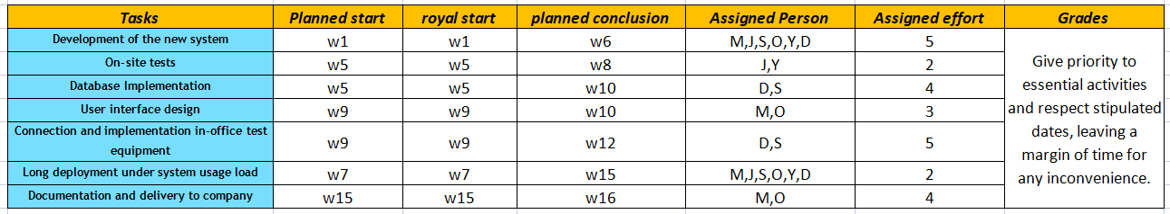

# *Capturas de pantalla*

# 

|  |  |  |  |  |  |  |  |  |  |  |  |  |  |  |  |  |
| --- | --- | --- | --- | --- | --- | --- | --- | --- | --- | --- | --- | --- | --- | --- | --- | --- |
| **Month** | **April** | | | | **May** | | | | **June** | | | | **July** | | | |
| **Week** | **1** | **2** | **3** | **4** | **5** | **6** | **7** | **8** | **9** | **10** | **11** | **12** | **13** | **14** | **15** | **16** |
| **Development of the new system** |  | | | | | |  |  |  |  |  |  |  |  |  |  |
| **On-site tests** |  |  |  |  |  | | | |  |  |  |  |  |  |  |  |
| **Database Implementation** |  |  |  |  |  | | | | | |  |  |  |  |  |  |
| **User interface design** |  |  |  |  |  |  |  |  |  | |  |  |  |  |  |  |
| **Connection and implementation in-office test equipment** |  |  |  |  |  |  |  |  |  | | | |  |  |  |  |
| **Long deployment under system usage load** |  |  |  |  |  |  |  | | | | | | | | |  |
| **Documentation and delivery to company** |  |  |  |  |  |  |  |  |  |  |  |  |  |  |  | |

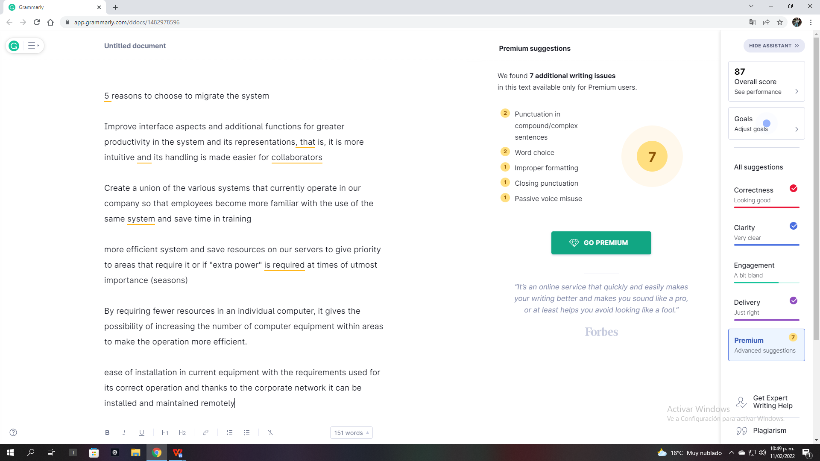

# *Conclucion*

For the coordination of projects, a series of steps must be followed in series that go from the planning of times and asking the questions: what am I going to do? At what time and what am I going to do in that time?

until the desired conclusion and application of the project, communication with the right people to propose your improvements and that they, in turn, understand your vision of things, attached to this have a diagram or visual elements that help make your idea more explicit they are very helpful.